**AL-IHSAN ACADEMY**

Teacher: Feraud Hamid Physical Science Accessment Test

Student Name…………………………………………………………………………..

Date: ………………………………………………. Class Grade: ……………………………………………………..

Scope: Chapter 1 coverage ( Lesson 1- 4)

Section: 1

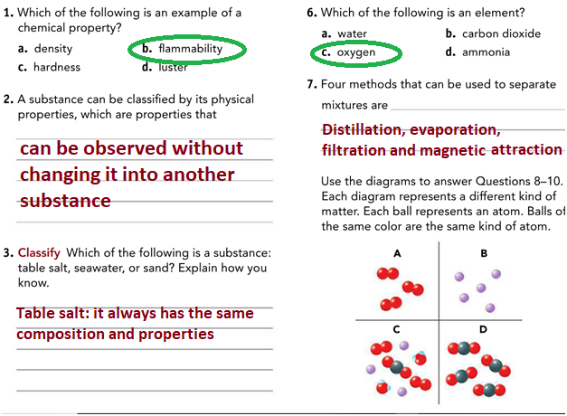

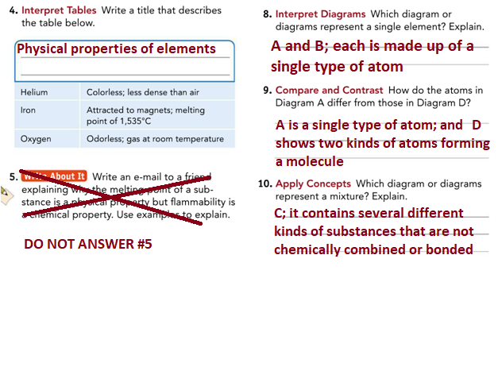

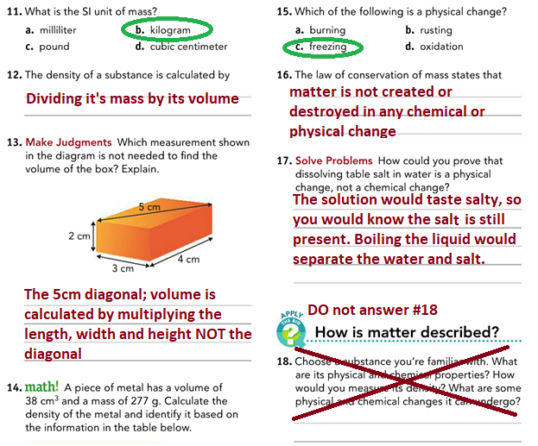

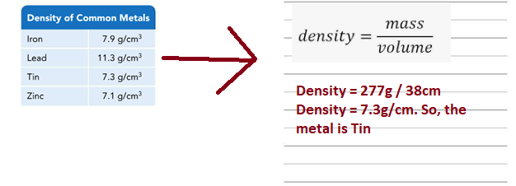

Section: 2

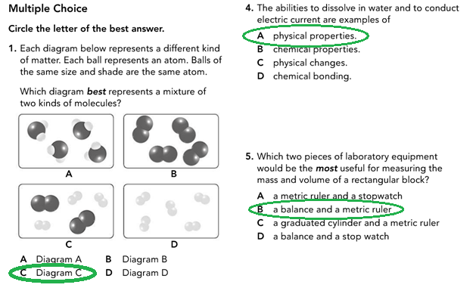

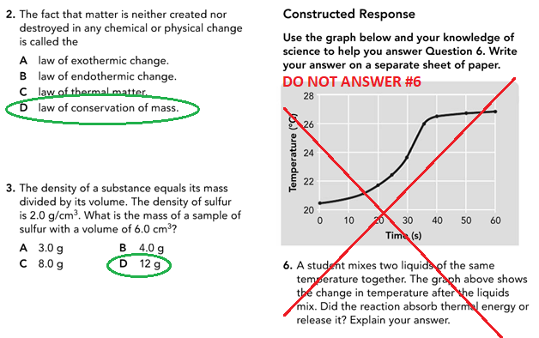

Section: 3

1. Define the below Terms:
2. Matter
3. Chemistry
4. Substance
5. Physical property
6. Chemical property

Answer:

1. ***Matter:*** Matter is anything that has mass and occupy space
2. ***Chemistry:*** Chemistry is the study of matter and how matter changes
3. ***Substance:*** Substance is a single kind of matter that is pure. E.g water
4. ***Physical property:*** A physical property is a characteristic of a substance that can be observed without changing it into another substance.
5. ***Chemical property:*** A chemical property is a characteristic that describes its ability to change into different substances.
6. What two properties are used to classify matter?

Answer: Physical and Chemical properties.

1. What are the three (3) states of matter?

Answer: Solid, Liquid and Gas

1. Recall definitions and answer the below:
2. A substance that cannot be broken down into any other substances by chemical or physical means is called ……………………………….?

Answer: An Element

1. The basic particle from which all elements are made is called ………………………………….?

Answer: An Atom

1. The force of attraction between two atoms is called …………………………?

Answer: A Chemical bond

d) When a group of two or more atoms are held together by a chemical bond, this is called a …………………………. ?

Answer: Molecule

e)A substance made of two or more elements that are chemically combined in a set ratio is called …………………………..?

Answer: A Compound

1. The type of formula that shows the elements in the compound and the combining ratios of their atoms is called ………………………………….?

Answer: A chemical formula

1. When two or more substances that are together in the same place BUT whose atoms are NOT chemically bonded or combined is called …………………………………………..?

Answer: A mixture

1. A type of mixture where the different parts can usually be seen and easily separated is called ……………………….?

Answer: A heterogeneous mixture

1. A type of mixture where the parts CANNOT be seen or separated easily is called ………………………

Answer: A homogeneous mixture

1. Recall definitions and answer the below:
2. The measure of the force of gravity on an object is called …………………………….?

Answer: Weight

1. The amount of matter that an object is made up of is called………………………………..?

Answer: Mass

1. To measure the properties of matter, scientists use a system called ………………………………..?

Answer: The International system of units

1. The amount of space matter occupies is called ……………………………..?

Answer: Volume

1. The measure of the mass of a material in a given volume is called ………………………………?

Answer: Density

1. What is the density of water?

Answer: 1 gram/cm3

1. The four methods discussed in your book to separate mixtures are Filtration, distillation, evaporation and ………………………………..?

Answer: Magnetic attraction

1. Recall definitions and answer the below:
2. The fact that matter is not created or destroyed in any chemical or physical change is called ……………………………………?

Answer: Law of conservation of mass

1. The measure of how hot or cold something is called……………………………….?

Answer: Temperature

1. The total energy of all the particles in an object is called…………………………………?

Answer: Thermal energy

1. A change in which energy is absorbed is called…………………………….?

Answer: Endothermic change

1. A change in which energy is released is called …………………………………?

Answer: Exothermic Change

1. The energy stored in the chemical bonds between atoms is called ………………………………?

Answer: Chemical energy